**Configuração básica de IP phone (VOIP) com Vlan de Dados**

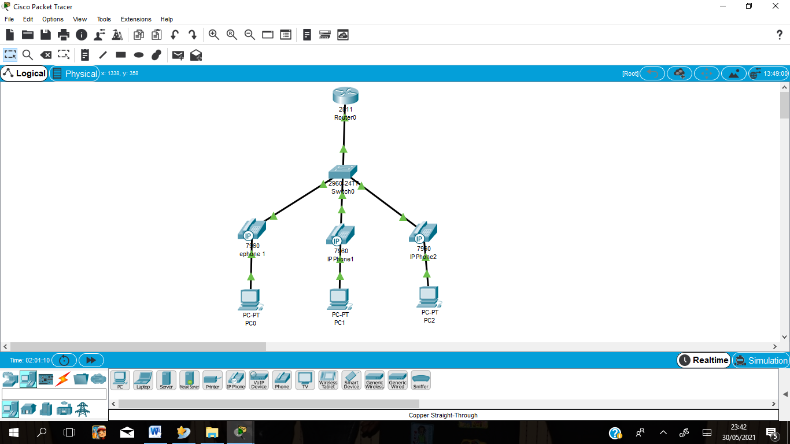

**1ª Passo: Configurações no Switch**

**Criar as VLANS de Dados, Voz, Gestão e Nativa**

Switch(config)#vlan 10

Switch(config-vlan)#name Dados

Switch(config-vlan)#exit

Switch(config)#vlan 20

Switch(config-vlan)#name Voz

Switch(config-vlan)#exit

Switch(config)#vlan 30

Switch(config-vlan)#name Gestao

Switch(config-vlan)#exit

Switch(config)#vlan 40

Switch(config-vlan)#name native

Switch(config-vlan)#exit

**Associar as portas nas VLANS**

Switch(config)#interface range f0/2-4

Switch(config-if-range)#switchport access vlan 10

Switch(config-if-range)#switchport mode access

Switch(config-if-range)#switchport voice vlan 20

Switch(config-if-range)#exit

**Habilitar a porta de Tronco**

Switch(config)#interface f0/1

Switch(config-if)#switchport trunk native vlan 40

Switch(config-if)#switchport mode trunk

**2ª Passo: Configurações no Roteador (2811)**

**Atribuir endereços nas sub-interfaces**

Router(config)#

Router(config)#interface f0/0

Router(config-if)#no shutdown

Router(config-if)#exit

Router(config)#

Router(config)#interface f0/0.10

Router(config-subif)#encapsulation dot1q 10

Router(config-subif)#ip address 192.168.10.1 255.255.255.0

Router(config-subif)#exit

Router(config)#interface f0/0.20

Router(config-subif)#encapsulation dot1q 20

Router(config-subif)#ip address 192.168.20.1 255.255.255.0

Router(config-subif)#exit

Router(config)#interface f0/0.40

Router(config-subif)#encapsulation dot1q 40 native

**Criar Pool (lista) DHCP para VLAN Dados e Voz**

Router(config)#ip dhcp excluded-address 192.168.10.1 192.168.10.5

Router(config)#ip dhcp excluded-address 192.168.20.1 192.168.20.5

Router(config)#ip dhcp pool Dados10

Router(dhcp-config)#network 192.168.10.0 255.255.255.0

Router(dhcp-config)#default-router 192.168.10.1

Router(dhcp-config)#exit

Router(config)#ip dhcp pool Voz20

Router(dhcp-config)#network 192.168.20.0 255.255.255.0

Router(dhcp-config)#default-router 192.168.20.1

Router(dhcp-config)#option 150 ip 192.168.20.1 (Pegar endereço de uma lista disponível)

**Configurar os IP phones (telefones IP)**

Router(config)#telephony-service

Router(config-telephony)#max-dn 3 (número máximo de directório(linhas telefónicas))

Router(config-telephony)#max-ephones 3 (número máximo de telefones)

Router(config-telephony)#ip source-address 192.168.20.1 port 2000 (Define a interface de voz e a porta de saída)

**Criar as extensões**

Router(config-telephony)#ephone-dn 1

Router(config-ephone-dn)#number 1010

Router(config-ephone-dn)#ephone-dn 2

Router(config-ephone-dn)#number 1020

Router(config-ephone-dn)#ephone-dn 3

Router(config-ephone-dn)#number 1030

Router(config-ephone-dn)#exit

**Associar os telefones as extensões criadas**

Router(config)#ephone 1

Router(config-ephone)#type 7960

Router(config-ephone)#mac-address 0010.1105.707C

Router(config-ephone)#button 1:1 (button-index:dn-index)

Router(config-ephone)#exit

Router(config)#ephone 2

Router(config-ephone)#type 7960

Router(config-ephone)#mac-address 00E0.B005.4A6A

Router(config-ephone)#button 1:2

Router(config-ephone)#exit

Router(config)#ephone 3

Router(config-ephone)#type 7960

Router(config-ephone)#mac-address 0004.9ABD.9B35

Router(config-ephone)#button 1:3

Router(config-ephone)#exit

**OBS: Com o comando:** Router(config-telephony)#auto assign 1 to 3**, vamos associar os telefones as extensões criadas sem entradas manuais dos dados dos telefones como: type, mac-address e button.**

Router#wr (Salvar as configurações)